**MATHEMATICS APPLICATIONS**

**YEAR 12 UNIT 3**

**TEST 2**

**GROWTH AND DECAY and GRAPHS AND NETWORKS**

**2023**



**PART A**

**CALCULATOR FREE**

TIME: 30 mins

MARKS: 34 marks

STUDENT’S NAME: _________SOLUTIONS_________________________

CIRCLE YOUR

TEACHER’S NAME: Mr Ismail Mrs Kalotay Ms Mack

Mrs Smirke Mrs Scoles Ms Tsen

Mrs Scoles

TUTOR GROUP

1. **8 marks** **[2,2,2,2]**

Consider the recurrence relation:

$${ t}_{n+1}={\frac{3}{2} t}_{n}, { t}_{1}=2$$

1. Complete the table to values showing the term number $(n$) and the term value ${(t}_{n})$ for the first five terms of the sequence.



|  |  |  |  |  |  |
| --- | --- | --- | --- | --- | --- |
| $$n$$ | 1 | 2 | 3 | 4 | 5 |
| $$t_{n}$$ | 2 | 3 | 4.5 | 6.75 | 10.125 |

1. Plot the graph on the given axes:

$t_{n}$

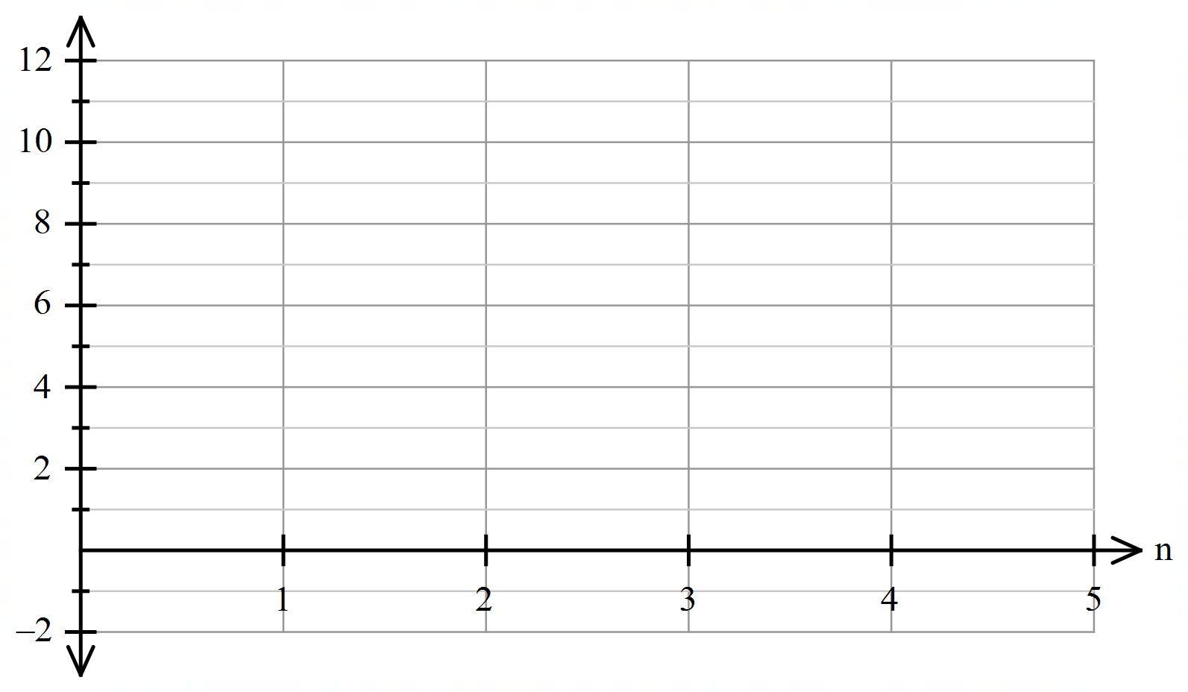



1. Describe the type of relationship.



Exponential growth or Geometric therefore exponential



1. Write the rule for the nth term



${ t}_{n}=2×( {\frac{3}{2})}^{(n-1)}$

1. **8 marks [4,2,2]**

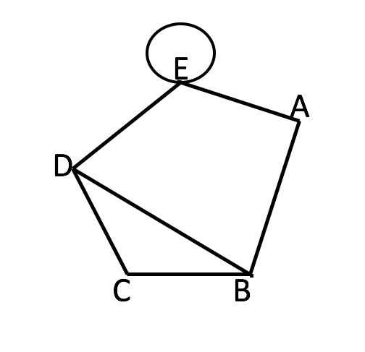

1. Using the network above, give the **best** name of the walk that is listed:

|  |  |
| --- | --- |
| **Walk** | **Name to describe walk** |
| DEEA | Open trail |
| CBA | Open path |
| DBAEABCD | Closed walk |
| ABCDEA | Hamiltonian, Hamiltonian cycle or Hamiltonian path |

1. State with reasons if the network above:
2. Is a simple graph

It is not simple because it contains a loop



1. Has a bridge

The is no bridge, as there is no edge which when removed makes the graph disconnected



1. **2 marks**

The following graph represents four islands and the bridges connecting them. Is the graph Eulerian, semi-Eulerian or neither. Justify your answer with reference to the graph.

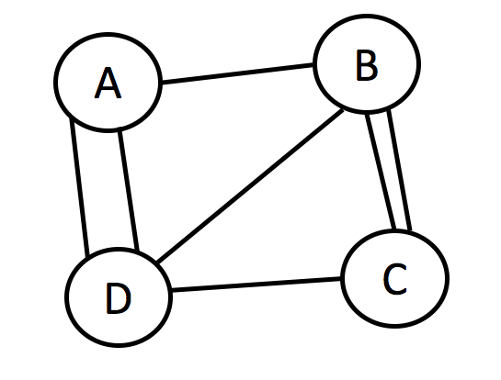Yes semi-Eulerian, must start and finish at A + C. Two odd vertices. CBCDBADA MPA



1. **5 marks** **[3,2]**

The accompanying diagram shows a 3-dimensional object.

1. Represent the following 3-dimensional object as a planar graph.

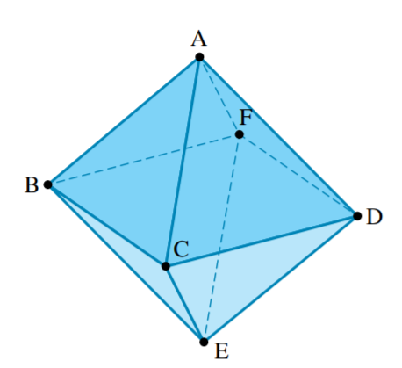

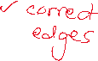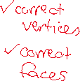

1. Show that the above graph satisfies Euler’s rule



1. **4 marks [2,2]**

A mathematical model is produced to predict the annual change in population of Echidnas in a remote area in Western Australia.

$U_{n}=1.1U_{n-1}-150, U_{1}=1760$**.**

1. Interpret the 1.1 and the -150 in the rule for this model.
   1. times the term means the population is increasing by 10% each year.



-150 means that 150 echidnas die each year



1. A newspaper claims that in the long-term, echidnas in this area will become extinct. Comment on this claim, using mathematics to support your answer.



No, the echidnas won’t become extinct, as the sequence is increasing, in the first year by 176 and only reducing by 150, so the 10% increase will always be greater than the loss of 150.

(Accept state increasing or explain increase, they don’t need to do both)

1. **3 marks [2,1]**

A fence is being constructed perpendicular to a road. The first fence post in the fence is 12 metres from the road, the next is 15.5 metres from the road and the next is 19 metres from the road. The rest of the fence posts are spaced out in this pattern.

1. Write the simplified general rule for the distance of fence post $n$ metres from the road.



$$t_{n}=12 +3.5(n-1)$$

$$t_{n}=8.5 +3.5n$$

1. If 100 posts are to be erected, how far will the last post be from the road?



$$t_{100}=8.5 +3.5(100) =358.5$$

1. **4 marks [2,1,1]**

The local council wants the road works manager to inspect each of the new traffic signals at each intersection of a new development as shown in the diagram below.

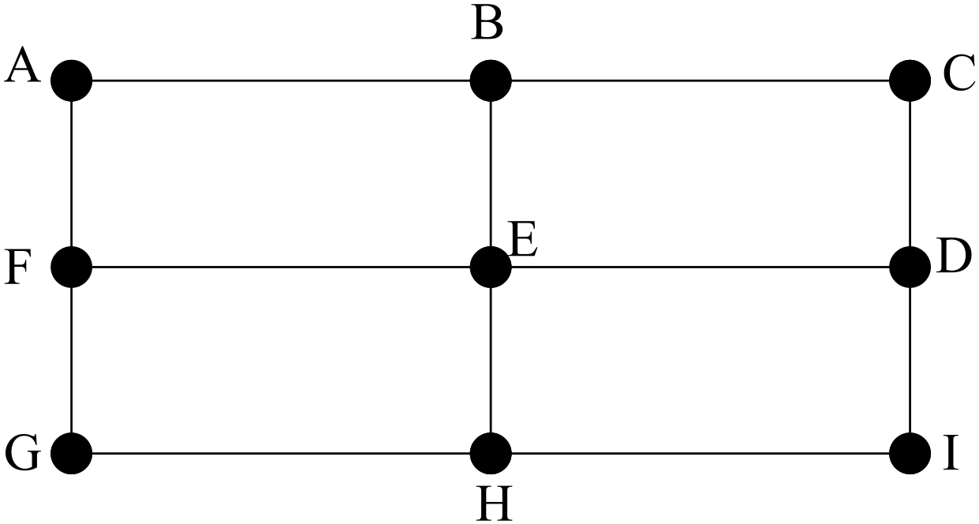

1. Is the graph semi-Hamiltonian? Explain



Yes, it is semi-Hamiltonian as you can travel through each intersection without repeating any or beginning and ending at the same intersection.

1. Add another road that needs to be travelled to make the graph Hamiltonian. Illustrate this on the diagram below.

MPA





1. For your new diagram above, where does the manager have to start?



Anywhere

End of Part A

**MATHEMATICS APPLICATIONS**

**YEAR 12 UNIT 3**

**TEST 2**

**BIVARIATE DATA and SEQUENCES**

**2023**



**PART B**

**CALCULATOR ASSUMED**

TIME: 20 mins

MARKS: 19 marks

STUDENT’S NAME: _________________________________________

CIRCLE YOUR

TEACHER’S NAME: Mr Ismail Mrs Kalotay Ms Mack

Mrs Smirke Mrs Scoles Ms Tsen

Mrs Scoles

TUTOR GROUP

`

1. **4 marks [2,2]**

After the rollout of the Covid-19 vaccination in the UK, the number of new diagnoses each day followed a geometric sequence. Each 24-hour period resulted in a 20% drop in new diagnoses.

Covid-19 test results were released at 6pm each day.

On 1st July 2021 at 6pm there were 33 000 new cases of Covid-19 diagnosed.

1. State a recursive rule to represent the number of new cases.



$${ t}_{n+1}={0.8 t}_{n}, { t}_{1}=33000$$

1. Calculate the number of diagnosed cases reported at 6pm on July 7th 2021.

8650.8 therefore approximately 8651 cases on July 7th



1. **3 marks [2,1]**

The owner of a renovation company has three tasks that need to be performed and three apprentices available to do these tasks.

The table below shows which possible tasks can be done by which possible apprentice.

|  |  |  |  |
| --- | --- | --- | --- |
| Apprentice | Task 1 | Task 2 | Task 3 |
| A1 | yes | yes | yes |
| A2 | yes | yes | yes |
| A3 | yes | yes | yes |

1. Draw up a bipartite graph to show the possible task allocation of the relevant apprentices.

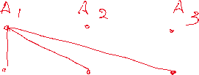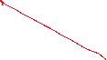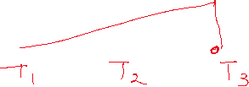

1. For this graph to be a complete bipartite graph, show or explain how the table would change. Fill the empty spaces in table with Yes or explain complete table



1. **8 marks [2,2,2,2]**

At the end of 1978, the population of Mandurah was approximately $10 000.$ Since then, it has experienced an average growth rate of 6.5% per year.

1. Create a recursive rule to model the population growth after $n$ years.



1. Complete the table below for the population of Mandurah, showing the population calculated at the end of the year.

|  |  |  |  |  |  |
| --- | --- | --- | --- | --- | --- |
| **Year** | **1978** | **1979** | **1980** | **1981** | **1982** |
| $$n$$ | 0 | 1 | 2 | 3 | 4 |
| **Population $P(n)$** | 10 000 | 10 650 | 11 342 |  |  |



1. What would be the predicted population for Mandurah at the end of 2024?



1. According to the *Local Government Act 1995,* a district can be classified as a city if its population exceeds $20 000$. Using this definition, at the endof which year was the district of Mandurah first entitled to be classified as a city?



1. **4 marks [1,1,1,1]**

Apple trees are growing in an orchard. Over time, some of the trees stop producing enough apples and are removed at the end of the year in which this first occurs. Immediately afterwards, a fixed number of new apple trees, $k,$ will be planted.

The total number of apple trees growing in the orchard at the end of the $nth$ year, $A_{n}$, immediately after the planting of the new apple trees for that year, is modelled by the equation:



$$A_{n+1}=0.84A_{n}+k A_{0}=18 000$$

1. What percentage of apple trees will be removed at the end of the year?



1. Assume 100 new apple trees are planted at the end of each year. Determine how many apple trees will be growing in the orchard at the end of the third year, immediately after the planting of the new apple trees for that year.



1. Assume, that $k=500,$ and the pattern continues as described above, how many trees will remain in the orchard, long term?



1. Determine the number of new apple trees, $k,$ that need to be planted at the end of each year so that there will always be $18 000$ apple trees growing in the orchard.



End of Test